Final Year Project

Declaration

I, Joseph Mckeown, of the Department of Computer Science, University of Reading, confirm that this is my own work and figures, tables, equations, code snippets, artworks, and illustrations in this report are original and have not been taken from any other person’s work, except where the works of others have been explicitly acknowledged, quoted, and referenced. I understand that if failing to do so will be considered a case of plagiarism. Plagiarism is a form of academic misconduct and will be penalised accordingly .I give consent to a copy of my report being shared with future students as an exemplar. I give consent for my work to be made available more widely to members of UoR and public with interest in teaching, learning and research.

Joseph Mckeown October 27, 2020

Abstract

Contents
Declaration 2
Abstract 3
Introduction 5
Literature Review 5
Project Aims and Objectives 5
Methodology 5
Implementation 5
Results 5
Analysis 5
Conclusion 5

Introduction

Background
This project is an exploration into how neural networks and be implemented in application to improve user satisfaction in the form of an android application where you can get a recommended outfit from a virtual wardrobe. The overall goal it to find how effective a simple neural network is when learning the tastes of a user and how this may lead to the user being more satisfied in the selection made leading to greater user retention. This project uses an application developed in android studio using java with the code being created from the ground up to provide an application which can run on most modern android devices.

Problem statement

Aims and Objectives
The aim of this project is to create an android application which will let the user randomise an outfits from their clothes. It aims to include features to improve the user experience like a recommender system, to give more accurate recommendation and connection to a weatherAPI, to factor in the current weather when creating an outfit. It will aim to prove that this implementation will lead to greater user satisfaction and can prove how an implementation of a neural network can learn the tastes of a user over time.
To achieve this an android application needs to be created as the host for the application. This application will need the functionality to be able to receive inputs from the user to create a digital wardrobe from which the neural network will choose the outfits. A neural network will need to be created frolling the multi-layer perception network approach. It will need to be able to learn how an item of clothing if reacted to individually and in relation to other the other clothes in the wardrobe. It will need an intuitive user interface which will allow ease of access to the users making it clear how to approach the application and to traverse it.

Solution Approach

Literature Review
Thing to talk about:
- The prominence of recommenser systems and algorithm designed to improve user experience like with social media and Netflix
- The Netflix coemption to create a better algorithm
- The use of reccomender system
- The danger of rellying too much on these kinds of algorithm based learning
- The great implementation of neural network
- The type of neural network and how they can be used.

Methodology

For the design of the application it needed to follow a basic formula. The main cycle of interactions from the user would be obtaining random outfits and deciding wether or not they like the outfits or not with the occasionally adding cloths to the application. With this in mind. The below design shows the guide on how the general function of the main screen of the application will be: 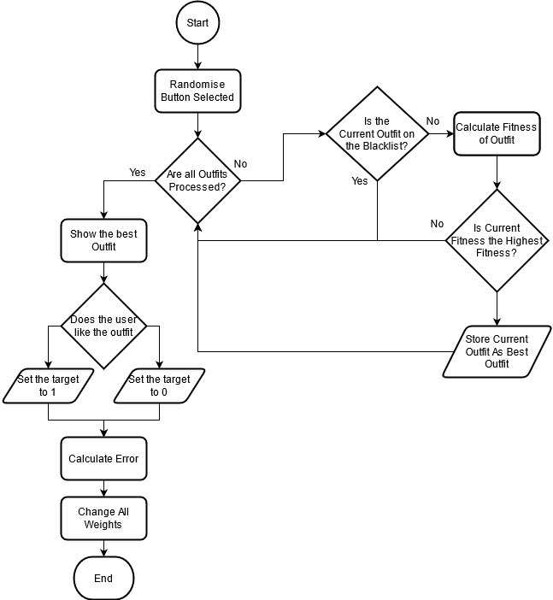
Figure 1 Flowchart of the general process of the main screen

With this key function are highlighted as the application will need the ability to calculate the fitness of an outfit, a way for the user to interact with it, and a way for the results to affect how the system function on future uses of the main function loop.

Clothing and Wardrobe System
Each item of clothing in the application would need to be classified as a type. The goal of which is to prevent item which would be incompatible in real life E.G. not wear 3 pairs of jeans. To achieve this, the clothes were sub-dived into 3 main categories being a Top, Under Top, Bottom as displayed below. The clothing classification allows for a simple and effective way to classify clothes and prevent conflicts when creating outfits. Along with this is can be expand in future development to included more sub-categories. This could be very useful as it can allow for preference in certain subtype of clothes to be tracked and influence the performance of an outfit, allowing for better user reactions.
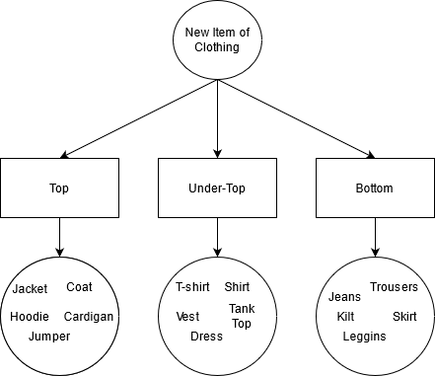
Fig : The Design of the Clothes Classification System

This would be implemented into a class within the application were each object in the class would contain the name, id, type of item which it is.
For the app to function as intended, a virtual wardrobe would need to be created. This is because there needs to be a method to stores all the items of clothing which are added to the application. This is done by taking the previously mention Clothes objects and storing them in a multidimensional ArrayList, the dimensions of which would be the same as the amount of type are to be used in the clothing classification. This is done to create an ease of access when creating an outfit to test. This is because the criteria would be one of each item from each dimension of the ArrayList. The reason an ArrayList is used specifically for the items of clothes is that the user needs the ability to add clothes to the wardrobe whenever they want and also remove items whenever the want. By storing it in a ArrayList is facilities this.

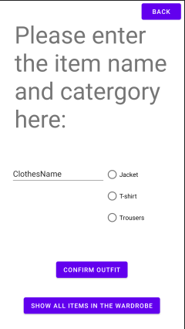
For the user to be able to do this a specific activity is created to facilitate this. The activity provides the user with the necessary information to understand how to traverse and interact with the screen.
Fig : The UI of the item adding activity
On the screen, the user is provided multiple options:
- 3 buttons which align with the sub-catergories for the clothes in the clothing classifier.
- A button to show all the items which are currently within the wardrobe
- Textbox for the user to input the name of the item of clothing
- Confirmation button which creates a new item of clothing in the wardrobe
For the user to process a new item of clothing by choosing the appropriate option. To ensure that an invalid item is not entered into the wardrobe, the option are checked on confirmation of the Item and once validate to have a name a type will be added to wardrobe. If adding the item is unsuccessful it will display a message in the middle of the screen on how to fix the issue.

The neural network
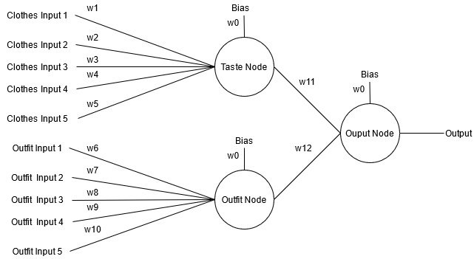
A model needed to be decied upon for the neural network as it is the core compenent to this application. The inputs and structure of the NN need to be established. For the inputs it takes the inputs from the current item of clothing/outfit being rated. So when let’s say clothes item has been chosen to find it’s value it will input a 1 while any other piece of clothing within the category will produce a 0 input. Each input has it’s own wiegth attached to it which will changed depending on the results from the users. Once the inputs have been calculated, this will produced a input for the hidden layer to the output WHICH I NEED TO MAKE FIRST. EXPLAIN WHY HIDDEN LAYER IS GOOD. The network is not fully connected as there are two sets of inputs. One for the clothes and the outfits being a combination of clothes. The amount of outfits is the amount of items of clothes in each category multiplied together so when there are 2 of each category there will 2*2*2 meaning there will be 8 possible outfits created so 8 possible inputs. The goal of separating the clothes inputs an the outfit inputs it to allow for the NN to learn how certain piece of clothes may not go well individually but may work really well in niche situation. Along with this it has the goal to learn wether taste in individual vlothes is more important or the synergu between the item is more important.

The problem trying to be solved is also not linearly seperable. Linear seperbily problem are those who can be can be defined by a straing line on if the it will be one result or not. This is better benefiting classification types of model with NN be can be considered within a predictive NN.
This type of NN is not using a data set and will learn unsupervised. Unsupervised learning is when it learn information without any tags attached to then. The described the application well as the algorithm will not know which kinds of outfits will be accepted or rejected by the user. This is due to the nature of clothing and how it is contanly changing in the tastes of the user. This is why the algorithm needs to be able to adapt quickly to new item being added to the system.
For the NN to be able to learn it will follow this structure. Once an outfit is requested by the user it will runs all the possible outfits through the NN. It will output the results for each outfit which will be compared to the other outputs of the other outfits. This can be considered the fitness of the outfit taking inspiration from some methods used within genetic algorithm. In GA fitness is computed on each generation and used to find which chromosomes in the population are best fit to reproduce and create the next generation. This is implemented in this MLP NN by having the having the fitness of the outfit compete against eachother. The selction process could be done in multiple ways such a roulette, rank or (FInd Another). The method I choose was rank selection for the outfit where the outfit which produced the highest result in the nueral network would be chosen to be presented to the user.
In a supervised nueral network, once the result was computed it would be compared to the target result and the change appropreitely. Unlike that in my unsupervided network the target is decided by the user. This is dictated by wether or not the user presses either of the accept or reject button within the GUI. This will set the target for the either 1 or 0 respecitvly. Once the target had be decie by the user, the NN will there change the relevant weight relating to the result. This will create the result where items of clothing which are less desired will show up a lower rate.
An issues which is procuded within this kind of system is that if only the best outfit is chosen by the network each time, the same outfit will be presented by the system on each run if the outfit was always accepted. To alliveate this a solution was introduced where once an outfit had been chosen it would be put onto a blacklist. This blacklist would exclude a chosen outfit from participating in the rank selction whilst on the blacklist. This work in a similar maner in which dataing site will not not repeat a selection once a decision has been made. However unlike those where the goal is to show as many people as possible, the user may want to use the same outfit again. This is why a timer isintroduced to the blacklist where, when the amount of clothes blacklisted exceed a portion of the overall wardrobe size it will add a random outfit back into the selection. This can also work well in the basis that an individual clothing item’s weighting may become higher or lower will the outfit’s would have changed little allowing for outfits which are like to be more likely to show up even after a an item of clothing has a poorperforame in other outfits.
Another way in which this issue can be overcome it through the other selection method of roulette as it this method gives a proportial chance of an outfit being chosen based on the fitness prodced from the NN. This means that outfits which score well are more likely to been chosen but still allow for other outfits to be chosen as well.

Problems (tasks) descriptionsAlgorithms/tools/technologies/etc. descriptionsImplementationsExperiments design and setup

the neural network has to
- Have a interatable ui with multiple screen/ acvtivies which the users can move through
- Creating an algorithm to predict the outfits
- A system to implement the clothes
- Ways to move the data through different screens
- Learning the problem
- Creating test cases to see how effective it is
- Preventing the best outfit from always being chosen or shown.
- Potential implementation of weather api
- Ability to store the information in the app form later usage
- Implementation of backpropgation
- Theory of how to implement a reccomender system and how that could implove the initial learning and the theory of online connectivity.
- How potentially implimnetaion of genetic algorithm can also be introduced to improve the performance as goal to find the fittest
- How the system was made to be ever evlovling with more items added.

Results

Analysis and Discussion

Conclusion and Future Works

